ASSIGNMENT 5:

AIM :
To use SQL and create a databse.

CODE:
create database factory;
use factory;
create table employee
(EMP_ID int not NULL Primary key,
FIRST_NAME varchar(20),
LAST_NAME varchar(20),
GENDER char(1),
SALARY int,
DEPARTMENT varchar(20));

insert into employee values(101, 'Monika', 'Arora', "F", 100000, 'HR'),
(102, 'Niharika', 'Verma', "F", 80000, 'Admin'),
(103, 'Vishal', 'Singhal', "M", 300000, 'HR'),
(104, 'Amitabh', 'Singh', "M", 500000, 'Admin'),
(105, 'Vivek', 'Bansal', "M", 500000, 'Admin'),
(106, 'Vipul', 'Singhal', "M", 300000, 'HR');

QUERIES:
#1
select FIRST_NAME as 'EMPLOYEE_NAME'
from employee
where FIRST_NAME like 'V%';
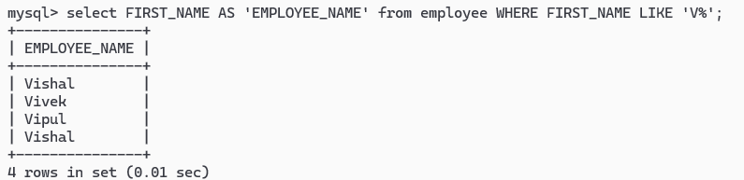
OUTPUT:
#2
select *
from employee
where DATE like "_____11%";
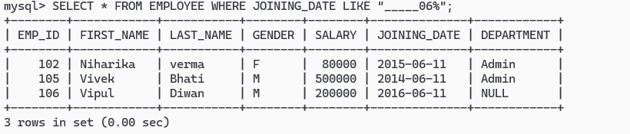
OUTPUT:
#3
select distinct DEPARTMENT
from employee
where DEPARTMENT is not NULL;
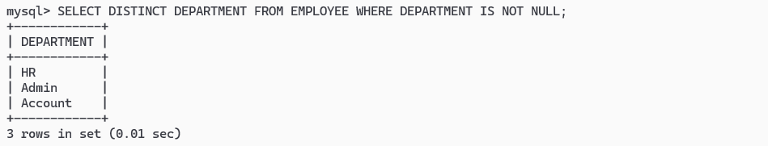

#4
select *
from employee
where DEPARTMENT is NULL;
OUTPUT:
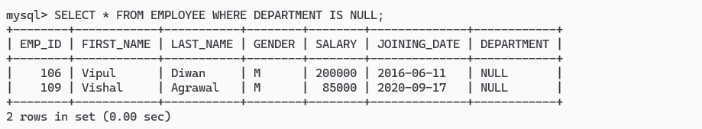

#5
select position('a' in FIRST_NAME)
from employee
where FIRST_NAME = "Amitabh";
OUPUT:
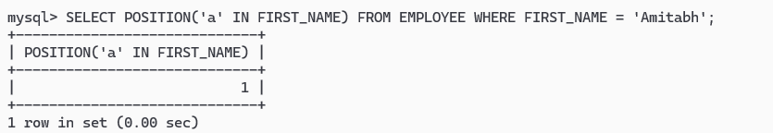
#6
select concat(FIRST_NAME, " " ,LAST_NAME) as "EMPLOYEE_NAME"
from employee;
OUTPUT:
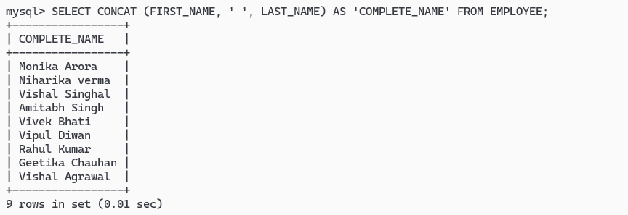
Query 7:
select first_name, salary
from employee
where emp_id in (select e_id from job where employee_title = 'manager') and gender='f';
Output:
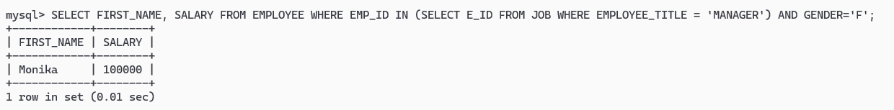
#8
select *
from employee
order by DEPARTMENT desc, FIRST_NAME;
OUTPUT:
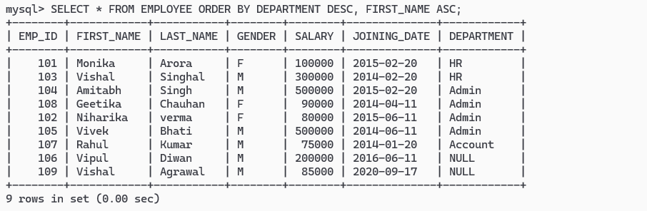

#9
select *
from employee
where SALARY > 100000 and SALARY < 500000;
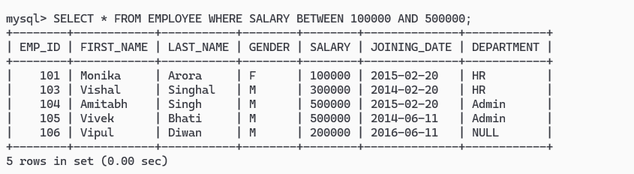

#10
select department, max(SALARY), min(SALARY), avg(SALARY)
from employee
group by department;
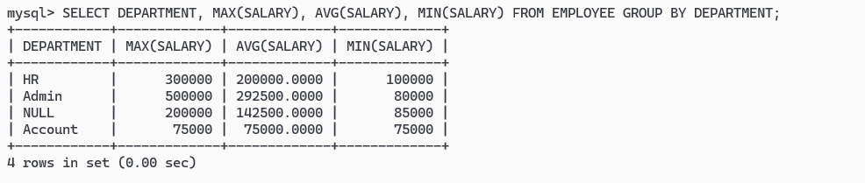
#11
select count(SALARY) as "SALARY"
from employee
where DEPARTMENT = "Admin";
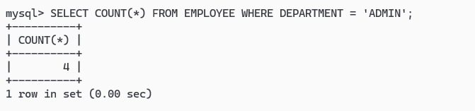

#12
select DEPARTMENT, count(EMP_ID)
from employee
group by department
order by SALARY desc;
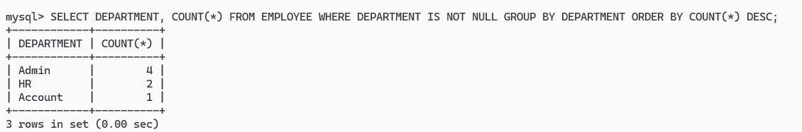

#13
select FIRST_NAME, SALARY
from employee
order by SALARY desc limit 1 offset 1;
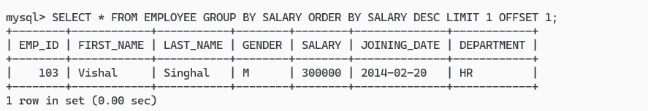

Query 14:
select *
from employee
where salary in (select salary from employee
group by salary having count(*) != 1 order by count(*) desc);

#15
select DEPARTMENT
from employee
group by DEPARTMENT
having count(EMP_ID) < 2;
OUTPUT:
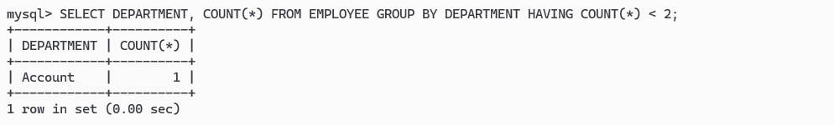

#16
select FIRST_NAME, SALARY, DEPARTMENT
from employee
where SALARY in (select max(SALARY) from employee group by DEPARTMENT);
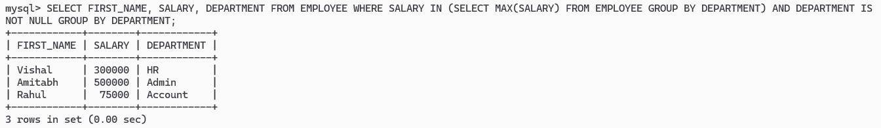

#17
select sum(salary), DEPARTMENT
from employee
group by DEPARTMENT;
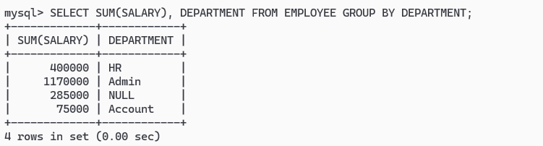

#18
select *
from employee, job
where employee.EMP_ID = job.E_ID and PROMOTION_DATE - DATE <20000;
OUTPUT:
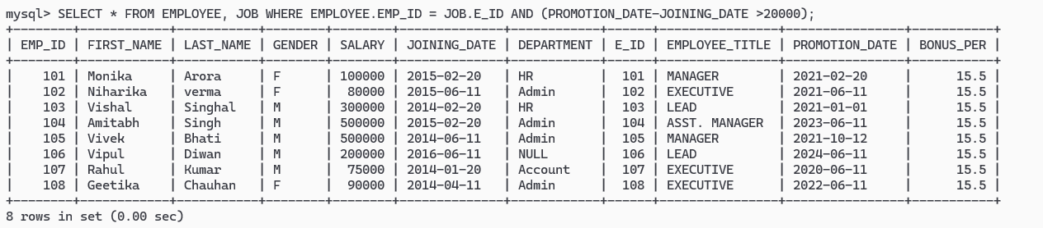

#19
alter table job
add column bonus_per int default 15.5;

#20
select FIRST_NAME, SALARY, bonus_per
from employee, job
where employee.EMP_ID = job.E_ID;

OUTPUT:
